**CHAPTER THREE**

**MATERIALS AND METHODS**

**3.1 Design and Analysis**

In this section, the various block/units and their circuit diagrams, design analysis, criteria and assumptions made for component selection are presented. Figure 3.1 shows the functional blocks of the designed circuit.

Power Supply

Level Unit

GPS Unit

MCU

GSM Unit

LED Unit

Legend

Power

Data

**Figure 3.1:** Schematics of the GSM based Tracker system

**3.1 Power Supply Unit**

The power supply unit is responsible for providing the biasing and operating voltage for the circuit operation. The input to this unit is 12V DC at a frequency of 0Hz and the output is 10.8V DC.

This unit comprises of the following basic components;

* Bridge diode
* 35V 1000uF and 25V 47uF capacitors
* LM7805 Voltage regulator
* 104Ω Resistors

**Selection of the Bridge Rectifier**

The rectification circuit used in the design is a full-wave bridge rectifier which comprises four diodes. This is shown in the figure below;

**D1 - D4 = IN 4007**

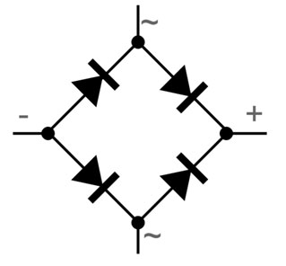

**Fig 3.2:** The Bridge Rectifier

The four diode Full Wave Bridge Rectifier is used due to its added advantage over a Two Diode center-tapped Full-Wave Rectifier as well as a One Diode Half-Wave Rectifier.

The choice of diodes used was based on:

1. The forward current rating: The diode forward current rating is the maximum current that the diode can conduct before failing. The diode is selected in such a way that the current passing through it is less than the forward current rating.
2. The *Peak Inverse Voltage* (PIV) that the diodes would withstand: The peak inverse voltage is the maximum reverse voltage that a diode can withstand without destroying the junction. If the reverse voltage across a diode exceeds this value, the reverse current increases sharply and breaks down the junction due to excessive heat. Peak inverse voltage is extremely important when diode is used as a rectifier. In rectifiers, it has to be ensured that reverse voltage across the diode does not exceed its PIV during the negative half-cycle of input ac voltage. Hence, PIV consideration is generally the deciding factor in diode rectifier circuit. The peak inverse voltage of a rectifier diodes lies between 10V and 10kV depending upon the types of diodes.

Vpeak = Vrms

Where *Vrms* is the battery’s output voltage using the maximum output voltage (that is 12V dc) we have that Vrms = 12V

∴Vpeak = Vrms = 12V(since the inputed voltage is DC)

For a bridge rectifier, the peak voltage equals the peak inverse voltage. Therefore, the calculated PIV is 12.0V.

Thus, the IN4007 diode was chosen for the rectifier since it satisfies the above stated requirements according to its datasheet.

Voltage drop across diodes = (2 x 0.7) = 1.4V

Voltage drop = 12.0 - 1.4 = 10.6V

Where 0.7 is the forward conducting voltage of a silicon diode.

**The Capacitor Selection**

The filter used in this power supply is a single shunt capacitor. The choice of the filter capacitor depends on:

1. The ripple factor allowed
2. The capacitor breakdown voltage
3. **The Ripple Factor Allowed**

The output of a rectifier consists of a dc component and an AC component (also called ripple). The ripple is undesirable and causes pulsations in the rectified output. The effectiveness of a rectifier depends on the amount of ripple in its output, the smaller this is, the more effective is the rectifier. The ripple factor is an indication of the effectiveness of the filter capacitor and is defined as:

Ripple Factor = = = =



The smaller the ripple factor, the lesser the amount of ripples and hence more effective is the rectified output signal. These ripples have a frequency of twice the input supply frequency. The ripple factor for full-wave rectifiers and thus allowed for this project is given as:

IRMS =



IDC =



∴ R = = 0.48



This shows that the DC component of the full-wave rectifier output is more than the ripples, making full wave rectifiers more suitable for rectifying ac to dc.

1. **The Capacitor Breakdown Voltage**

The capacitor breakdown voltage can be determined by applying Kirchhoff’s voltage law at the output of the rectifier to the terminal of the filter capacitor.

Vpeak – 2 (Diode drop (VD)) = Voltage at filter capacitor

For silicon made diode VD ­= 0.7V

∴ VC = 12.0 – 2 (0.7) = 10.6V

Taking a safety factor of two, the capacitor voltage, VC becomes 21.2V, and since this is not a common capacitor voltage, a 25V capacitor was chosen

The capacitance of the capacitor used is gotten using the relationship:

27

Vmax = IL/C

IL = load current = 41.60mA (as calculated)

C = capacitance

Maximum peak = 12.0V

Obtaining capacitance, we have that: Vmax= IL/C= 41.60 x 10-3

C

12.0 = 41.60 x 10-3

C

C = 41.60 x 10-3

12

Therefore, C = 41.60 x 10-3 = 0.00003618711F = 3466µF

12.0

From the calculated value, 3466μF is not a standard capacitance value; hence a 2200μF, 25V capacitor was selected.

**The Voltage Regulator Selection**

The importance of voltage regulator is to ensure that a fixed voltage output is obtained at the output of the power supply regardless of the variations from the supply input or load connected. The regulation used is the IC voltage regulator LM2596. This implies that a positive fixed +5volts regulator was used to provide the fixed positive voltage level required by the circuitries.

The rating of the voltage regulator from the datasheet is as given below:

1. Input voltage range 5~40V
2. Maximum current rating 5mA-1.5A
3. Output voltage range 1.8~30V
4. Operating temperature range 0~125℃

The positive IC voltage regulator was chosen from the LM family of positive voltage as they are more efficient in providing the much-needed constant voltages for the interconnected circuitries of the design.

## 3.1.2 SELECTION OF THE GSM/GPRS MODULE UNIT

This unit enables the microcontroller to send and receive data over the IOT Network.

After research, this unit was implemented with SIM800L Module from SIMCOMM Group. Below are some of its features:

* It uses RS232 serial communication protocol that is TX, RX and common terminal.
* It uses GSM/GPRS AT command sets. Easy protocol for the microcontroller
* It operates with 5V DC at 100m A
* It requires no biasing components and available and cost effective

The  SIM800L is a cheap and portable GSM breakout board with all the capabilities of the larger SIM900 shields. Here are the features of the SIM800A breakout board:

* 2G quad-band @ 850/900/1800/1900 MHz
* Receive and make calls using the speaker and microphone outputs
* Receive and send SMS
* Connect to the Internet via GPRS
* Listen to FM radio broadcasts
* Accepts AT Commands

The Unit directly interfaced with the microcontroller. Below are the AT Command sets used between the microcontroller and the SIM800L Module to transmit over the IOT.

AT + RST

AT + CIPMODE=1

AT + CIPSTART=” TCP”,” mathworks.net”,80

AT + CIPSEND

GET /iot/data.php?level&time&date HTTP/1.1

Host: mathworks.net

See appendix A for complete source code. Below is the circuit interface between the microcontroller and the GSM/GPRS Module unit.

## **Hardware Overview**

At the heart of the module is a SIM800L GSM cellular chip from Simcom.The operating voltage of the chip ranges from 3.4V to 4.4V, making it an ideal candidate for direct LiPo battery supply. This makes it an excellent choice for embedding in projects with limited space.

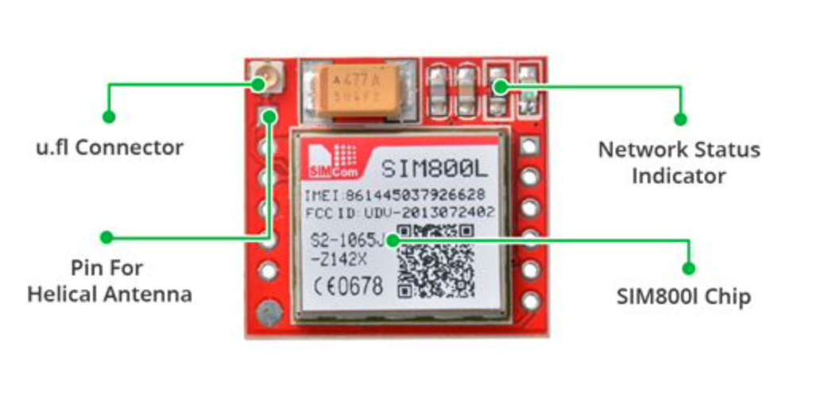

# **Fig.3.3: The GSM/GPRS Module Unit**

All the necessary data pins of the SIM800L GSM chip are broken out to a 0.1″ pitch headers, including the pins required for communication with the microcontroller over the UART. The module supports baud rates ranging from 1200 bps to 115200 bps and features automatic baud rate detection.

The module requires an external antenna in order to connect to the network. So the module usually comes with a helical antenna that can be soldered to it. The board also has a U.FL connector If you wish to keep the antenna at a distance from the board.

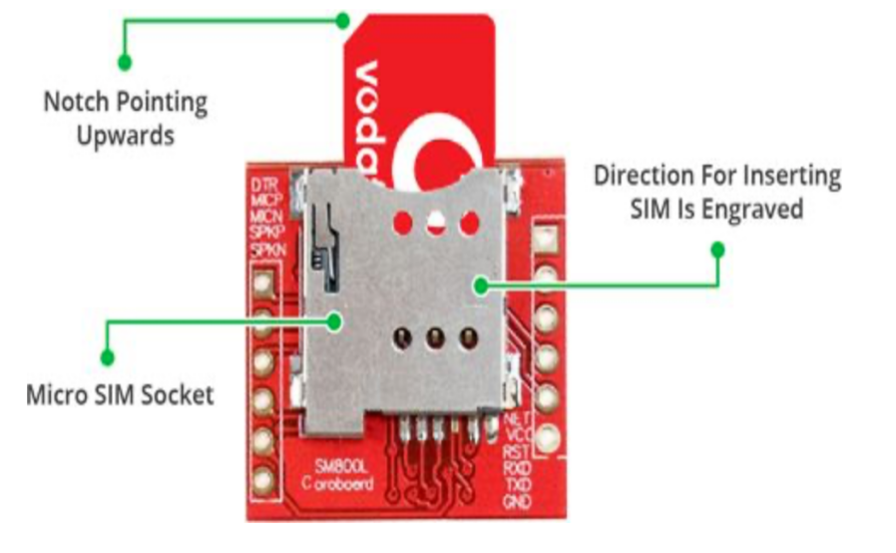

**Fig 3.4:** The SIM Card Unit

There’s a SIM socket on the back! Any 2G Micro SIM card will work perfectly. The proper way to insert the SIM card is typically engraved on the surface of the SIM socket.

## Choosing an Antenna

The SIM800L module requires an external antenna in order to connect to the network, so choosing the right antenna is very important. There are two options available.

The first is a helical antenna that comes with the module and can be soldered directly to the PCB. This antenna is very useful for space-constrained projects.

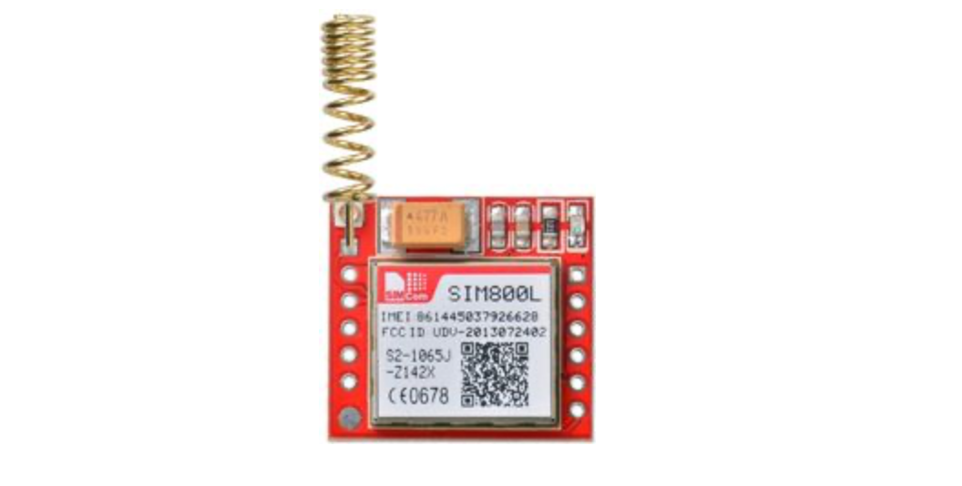

**Fig 3.5:** The helical antenna

Another option is a 3dBi GSM antenna with a U.FL to SMA adapter, which can be found online for less than $3. 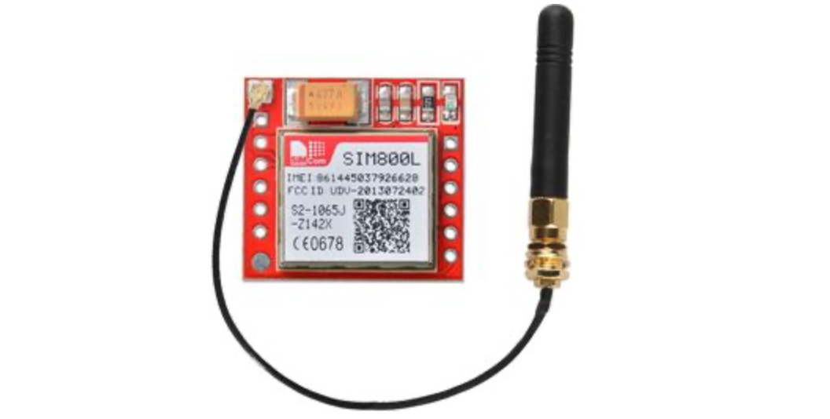

**Fig 3.5:** The 3dBi GSM antenna

## Power Consumption

One of the most important parts of getting the SIM800L module working is supplying it with enough power.The SIM800L, depending on its state, can be a relatively power-hungry device. The module’s maximum current draw is around 2A (especially during a transmission burst). It won’t usually draw that much, but it may need around 216mA during phone calls or 80mA during network transmissions. This chart from the datasheet summarizes what you can expect

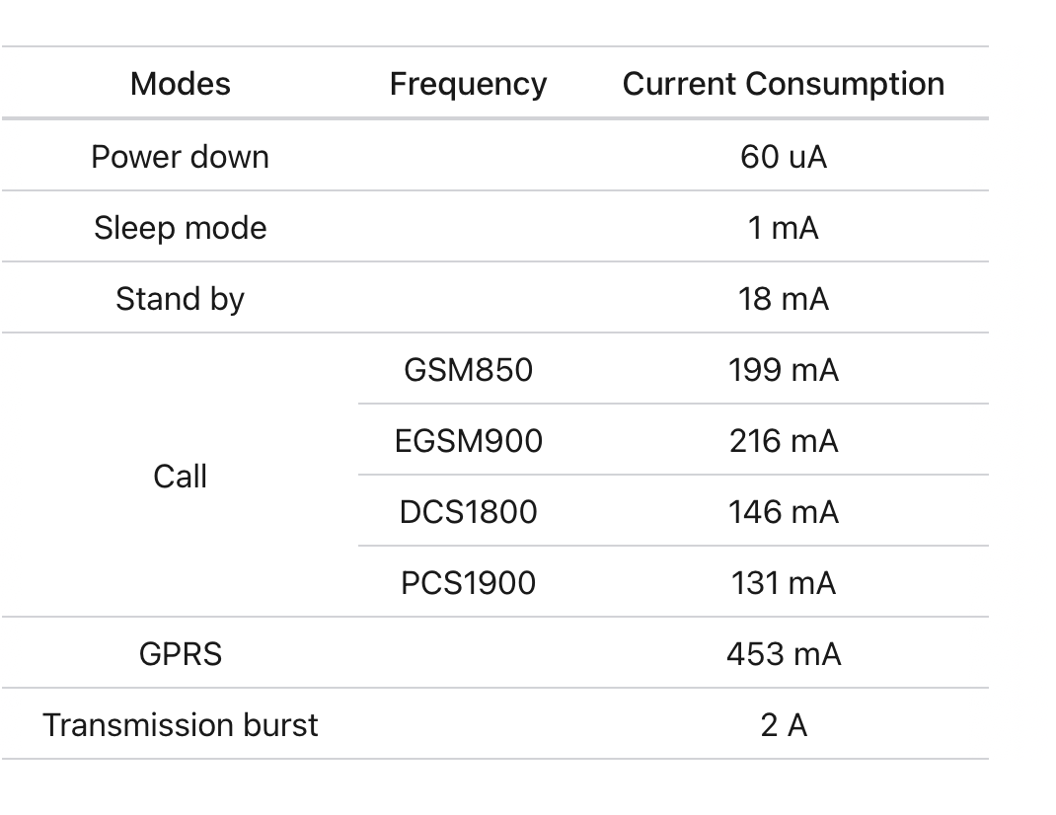

## **Fig 3.5:** The specification

## Selecting a Power Supply

Because the SIM800L module lacks an onboard voltage regulator, you must select a power supply capable of supplying the SIM800L module within its 3.4V to 4.4V range (preferably 4.0V). Also the power supply must be capable of supplying at least 2A of surge current; otherwise, the chip will repeatedly reset.

## SIM800L GSM Module Pinout

The SIM800L module has 12 pins in total. The following is the pinout:

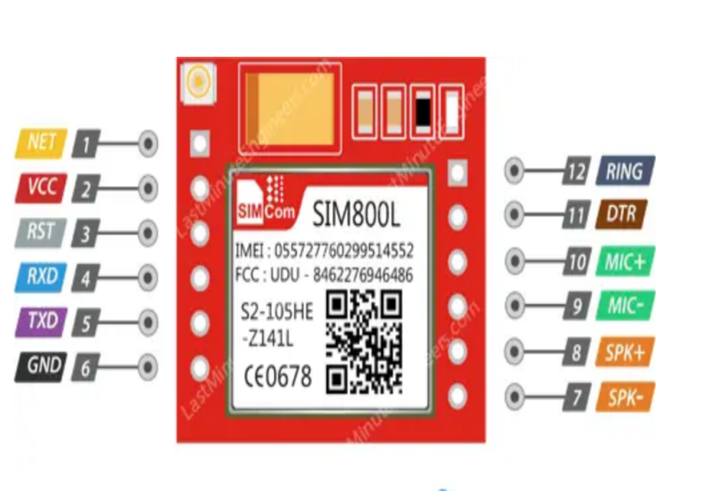

## **Fig 3.5:** The SIM800L GSM Module Pinout

* NET pin is where you can solder the helical antenna that comes with the module.
* VCC is the power supply pin. Keep in mind that the SIM800L chip has an operating voltage range of 3.4 V to 4.4 V, so connecting this module to the Arduino’s 5V output is probably going to cause damage to the module.
* RST is the reset pin. If you got the module in an absolutely bad space, pull this pin LOW for 100ms to perform a hard reset.
* RxD(Receiver) pin is used to send commands to the module. This pin is auto-baud so the baud rate at which you send the “AT” command after reset is the baud rate used.
* TxD(Transmitter) pin transmits data from the module to the microcontroller.
* GND is the ground pin.
* RING pin is the Ring Indicator. This is basically the ‘interrupt-out’ pin from the module. It is by default HIGH and can be configured to go LOW when a call or SMS is received.

## Wiring a SIM800L GSM Module to an Arduino

To begin, the antenna was connected to the module and a micro SIM card was inserted into the socket.Next, Tx pin was connected to the Arduino's digital pin #3, as communication would be handled via software UART. However, the module’s Rx pin could not be connected directly to the Arduino’s digital pin due to the difference in logic levels—the Arduino UNO operates at 5V, while the SIM800L module uses 3.3V. Specifically, the SIM800L module's Rx pin was not 5V tolerant, so the Tx signal from the Arduino had to be stepped down to 3.3V. One of the simplest ways to achieve this was by using a resistor divider. A 10K resistor between the SIM800L’s Rx pin and Arduino’s D2, along with a 20K resistor between the SIM800L’s Rx pin and GND, was suggested as a solution. Finally, it was mentioned that the power supply needed to be connected to the module, with two different wiring diagrams provided to illustrate the setup

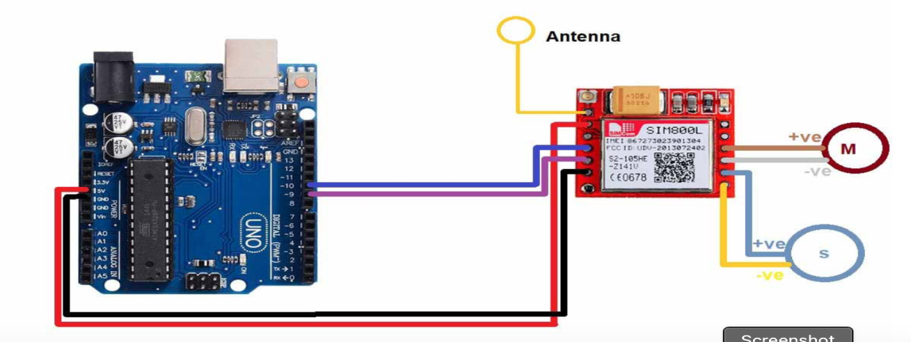

## **Fig 3.9:** The connection of the SIM00L

## 3.1.3 SELECTION OF THE GPS MODULE UNIT

At the heart of the module is a GPS chip from U-blox – NEO-6M. The chip measures less than a postage stamp but packs a surprising amount of features into its tiny frame.It can track up to 22 satellites over 50 channels and achieve the industry’s highest level of tracking sensitivity i.e. -161 dB, while consuming only 45 mA current.Unlike other GPS modules, it can perform 5 location updates in a second with 2.5m horizontal position accuracy. The U-blox 6 positioning engine also has a Time-To-First-Fix (TTFF) of less than 1 second. One of the best features offered by the chip is Power Save Mode (PSM). This allows a reduction in system power consumption by selectively switching certain parts of the receiver on and off. This dramatically reduces the power consumption of the module to just 11mA making it suitable for power sensitive applications such as GPS wristwatches.The required data pins of the NEO-6M GPS chip are broken out to a 0.1″ pitch headers. It contains the pins needed for communication with the microcontroller over the UART. The module supports baud rates from 4800bps to 230400bps with a default baud of 9600.

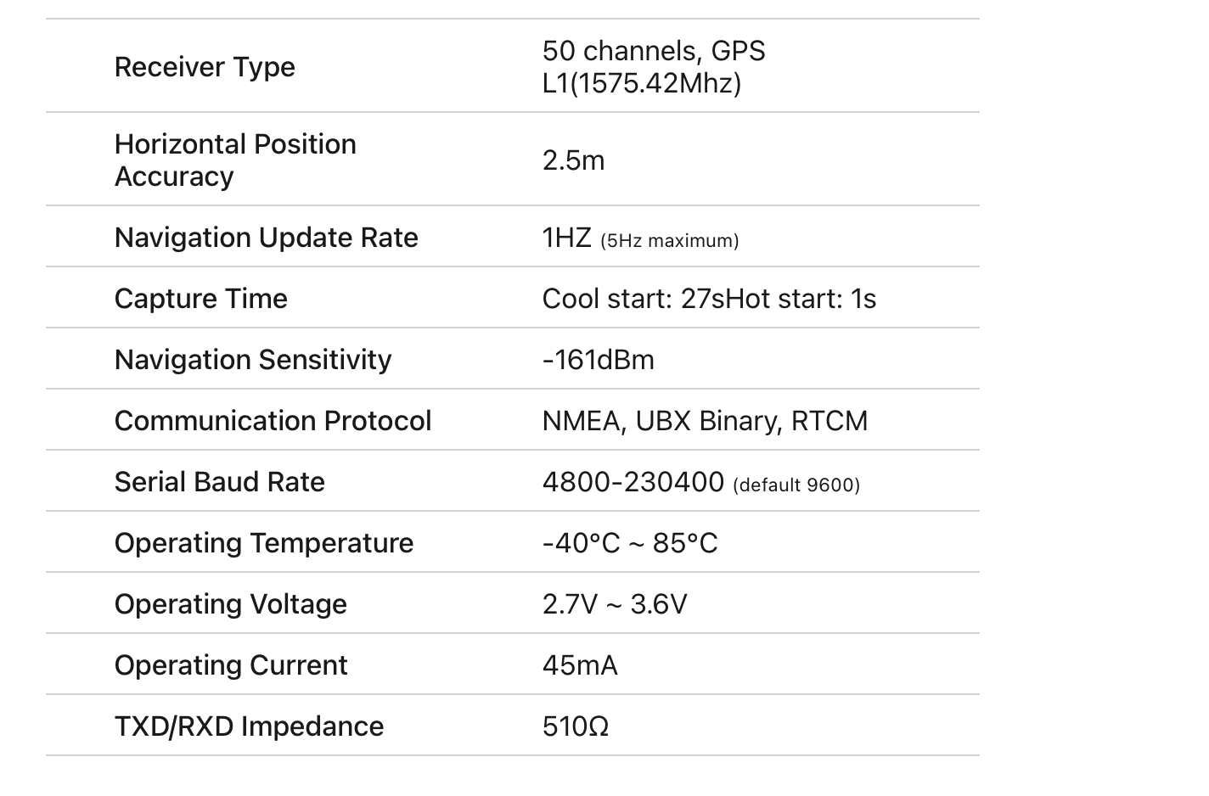

## **Fig 3.10:** The Technical specification

### Antenna

The module comes with -161 dBm sensitivity patch antenna for receiving radio signals from GPS satellites.

The patch antenna is great for most of our projects. But if you want to get more sensitivity and accuracy, you can also snap-on any 3V active GPS antenna.

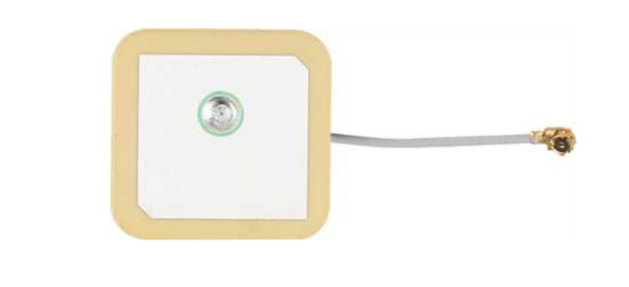

## NEO-6M GPS Module Pinout

The NEO-6M GPS module has a total of 4 pins that connect it to the outside world. 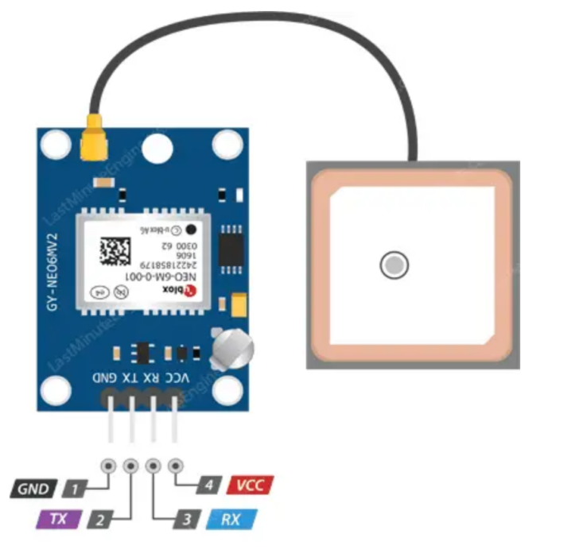

## **Fig 3.11:** The pinout of the GPS Module

**GND** is the ground pin and needs to be connected to the GND pin on the Arduino.

**TxD(Transmitter)** pin is used for serial communication.

**RxD(Receiver)** pin is used for serial communication.

**VCC** supplies power to the module. You can connect it directly to the 5V pin on the Arduino.

## 3.1.4 SELECTION OF HC-SR04 Ultrasonic Sensor Pinout

The Ultra Sonic HC-SR04 emits ultrasound at 40,000Hz that travels in the air. If there is an object or obstacle in its path, then it collides and bounces back to the Ultra Sonic module. The formula **distance = speed * time** is used to calculate the distance. Suppose, an object is placed at a distance of 10 cm away from the sensor, the speed of sound in air is 340 m/s or 0.034 cm/µs. It means the sound wave needs to travel in 294 µs. But the Echo pin double the distance (forward and bounce backward distance). So, to get the distance in cm multiply the received travel time value with echo pin by 0.034 and divide it by 2. The distance between Ultra Sonic HC-SR04 and an object is:

distance = (speed * time)/ 2

Speed of Sound:

speed = 340m/s = 0.034cm/us

time = 10 /0.034us = 294us

distance = (speed * time)/2

distance = (0.034 * 294)/2

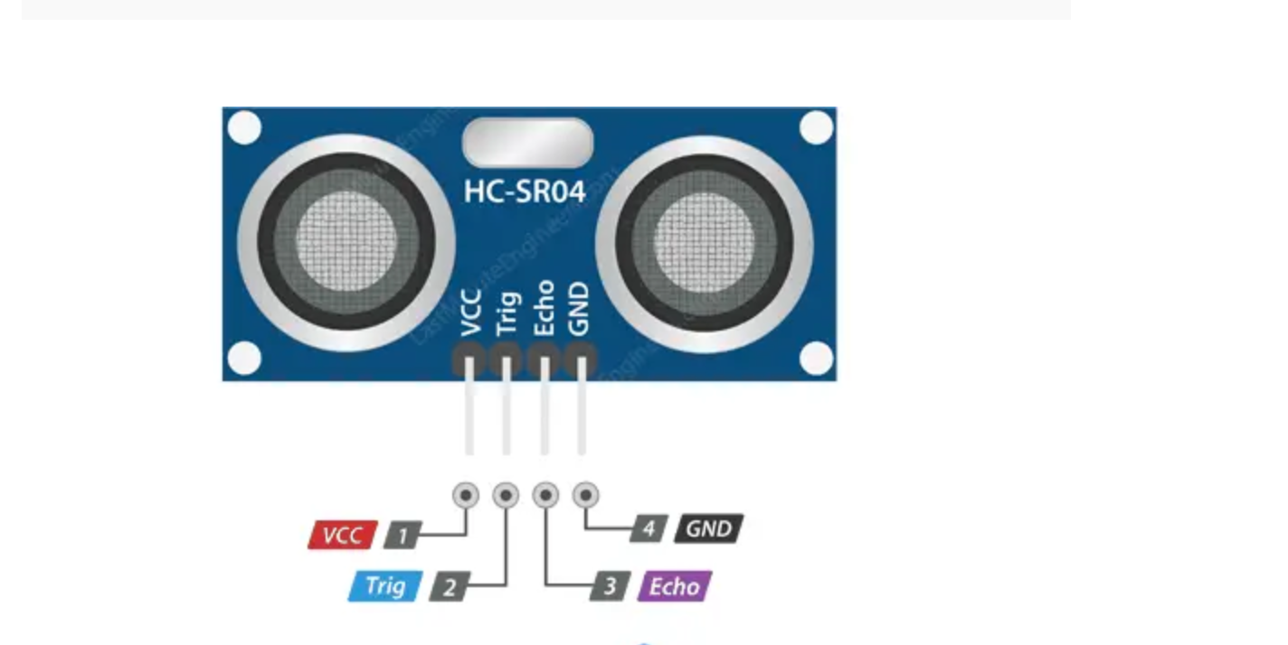

Fig 3.7: Pinout of Ultrasonic Sensor

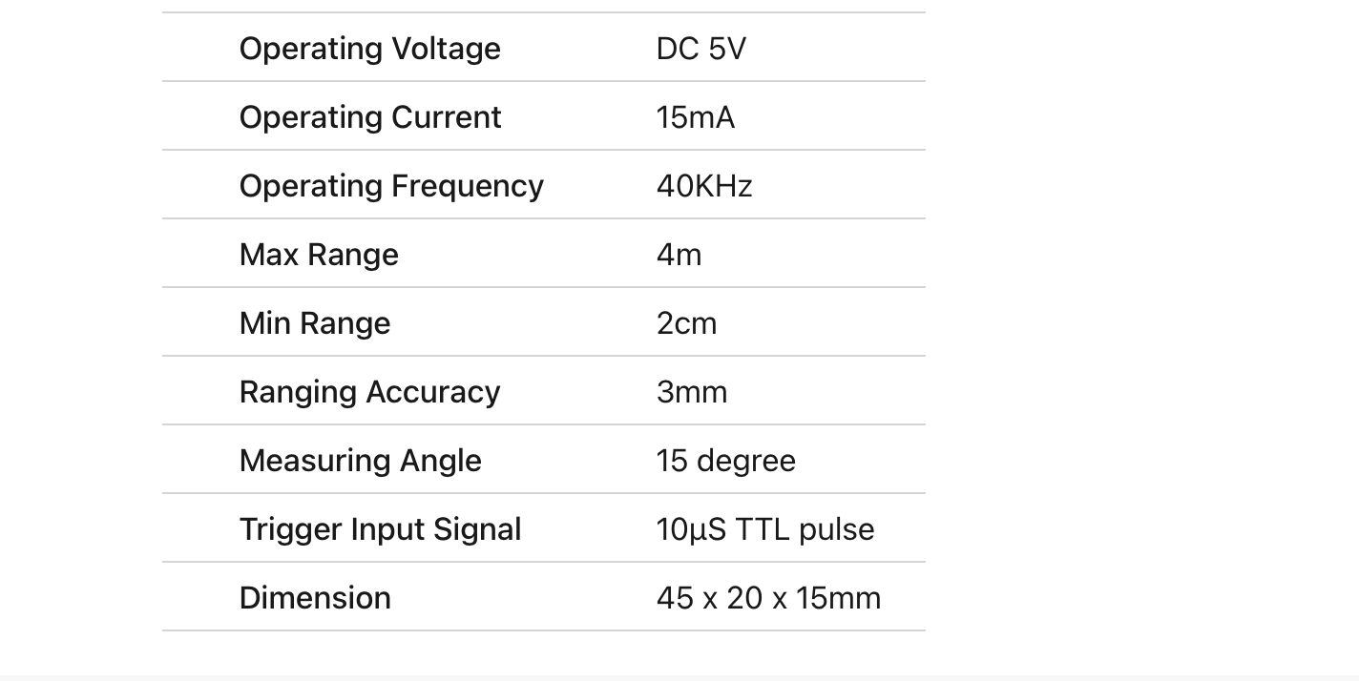

### Fig 3.8: Technical Specifications of Ultrasonic Sensor

## 3.1.5 SELECTION OF LED

LED stands for **Light Emitting Diode**. They are a special type of diode that convert electrical energy into light. They have very similar electrical characteristics to a normal [PN junction diode](https://lastminuteengineers.com/pn-junction-diode/). That’s why the symbol of LED is similar to the normal PN junction diode except that it contains arrows pointing away from the diode indicating that light is being emitted by the diode.

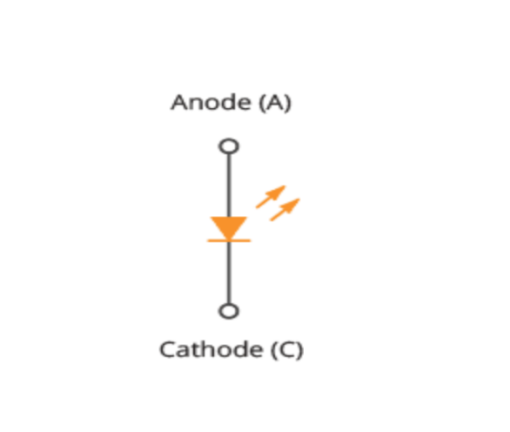

Fig 3.9: Schematic of a LED

## LED Construction

LEDs are so common, they come in a huge variety of shapes, sizes and colors. The LEDs you are most likely to use are the standard through hole LEDs with two legs. Following figure shows the parts of it.

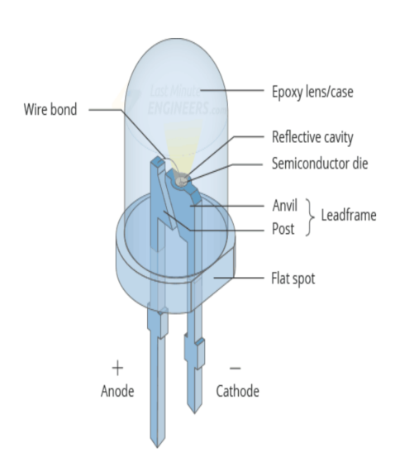

Fig 3.10.0: Internal view of LED Construction

The construction of an LED is very different from an ordinary diode. The PN junction of an LED is surrounded by a transparent, rigid plastic epoxy resin shell.The shell is constructed in such a way that photons of light emitted by the junction are focused upward through the domed top of the LED, which itself acts like a lens. This is why the emitted light appears brightest on top of the LED.Just as in an ordinary diode, the positive side of the LED is called the **Anode**, while the negative side of the LED is called the **Cathode**. The cathode is usually indicated by having a shorter lead than the anode. Not only this, the outside of the plastic case typically has a flat spot or notch which can also indicate the cathode side of the LED.Not all LEDs are hemispherical in shape, some are rectangular while some are cylindrical, but they are mostly constructed in the same way.

## LED Working

Like an ordinary diode, the LED operates only in forward bias condition. When the LED is forward biased, the free electrons cross the PN junction and recombine with holes. Since these electrons fall from a higher to a lower energy level, they radiate energy in the form of photons (light).

In ordinary diodes, this energy is radiated as heat while in an LED, energy is radiated as light. This effect is called **Electroluminescence**.

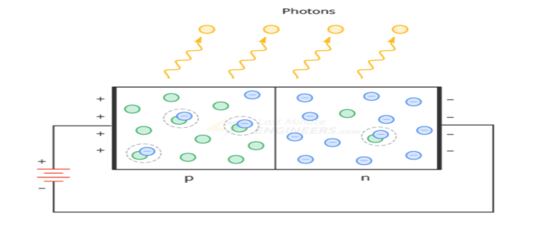

Fig 3.10.1: Internal view of LED PN-junction

## LED Colors

Light emitting diodes are available in a wide range of colors with the most common being red, green, yellow, blue, orange, white and infrared (invisible) light.

Unlike ordinary diodes that are made of germanium or silicon, LEDs are made of elements such as gallium, arsenic, and phosphorus. By mixing these elements together in different proportions, a manufacturer can produce LEDs that radiate different colors as shown in the table below.

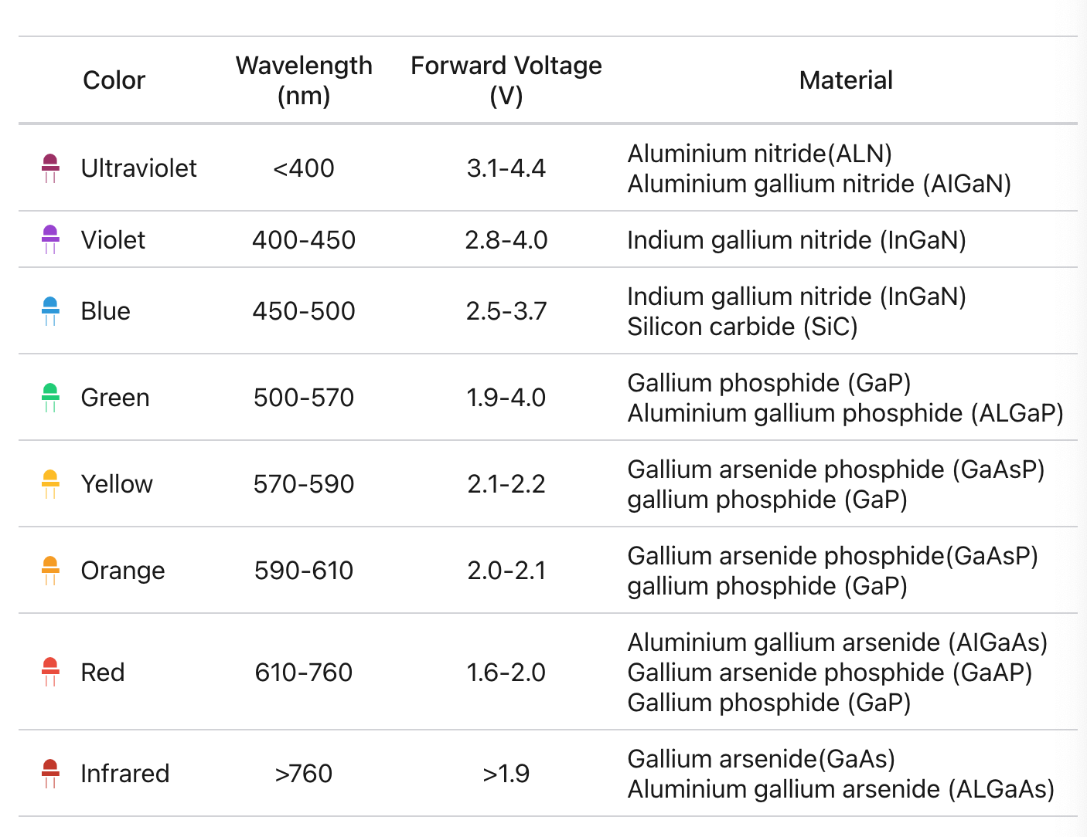

Fig 3.10.1: Led colors specifications

The actual color of an LED is determined by the wavelength of light emitted, which in turn is determined by the actual semiconductor material used to make the diode.

Therefore the color of the light emitted by an LED is NOT determined by the color of the body of the LED. It just enhances the light output and indicates its color when it is not illuminated.

## LED Voltage and Current

For most low-power LEDs, the typical voltage drop is from 1.2V to 3.6V for currents between 10mA to 30mA. The exact voltage drop will of course depend upon the semiconductor material used, color, tolerance, along with other factors.

As the LED is basically a diode, its IV characteristics curves can be plotted for each color as shown below.

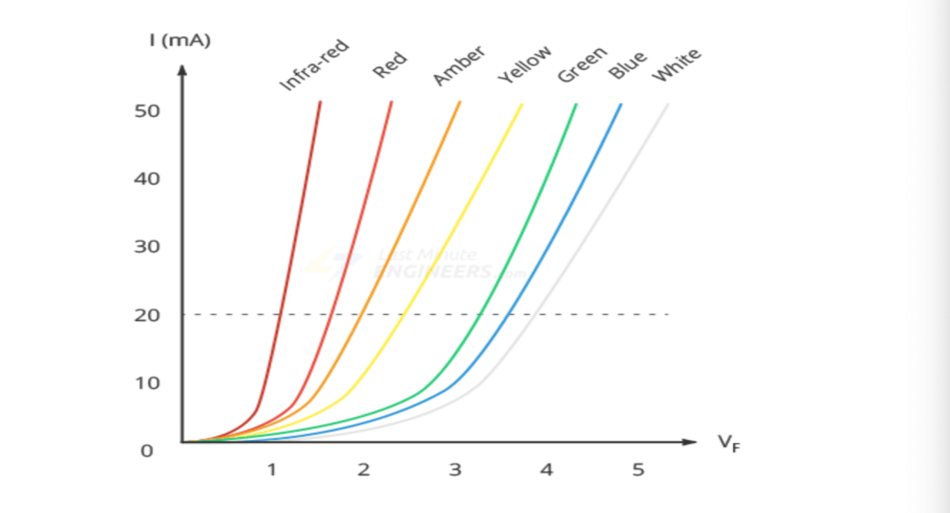

Fig 3.10.2: Led colors against current demand

## LED Brightness

The brightness of an LED depends directly on how much current it draws. The more current it draws, the brighter the LED will be.You can control the brightness of an LED by controlling the amount of current through it.

## The Current Limiting resistor

If you connect an LED directly to a battery or power supply it will try to dissipate as much power as possible, and, it will destroy itself almost instantly.

Therefore it is important to limit the amount of current flowing through the LED. For this, we use resistors. The resistor limits the flow of electrons in the circuit and prevents the LED from trying to draw too much current.

The current-limiting resistor is placed between LED and voltage source in this way:

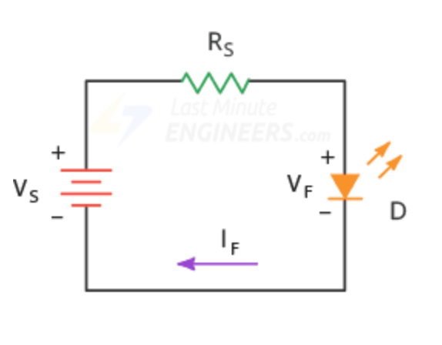

Fig 3.10.2: Led circuit design

In above circuit, the resistor has a node voltage of VS on the left and a node voltage of VF on the right, the voltage across the resistor is the difference between the two voltages.

By applying Ohm’s law, the current-limiting resistor is calculated as:

Rs = Vs-Vf / If

## 3.1.6 **THE CONTROLLER UNIT**

This Unit is the Heart of the Entire System. It performs the entire logic of the system. Below is the requirements of the controller unit.

**Requirements of the Controller**

* Should be able to interface the GSM unit.
* Should have UART Module required to interface the GSM/GPRS Module
* Should be stable and efficient.
* Should have enough Input/output Pins to accommodate the entire system.
* Should be easily programmed.
* It should available and cost effective.

**Selection of the Controller**

The Atmega328p Microcontroller From Microchip Corporation was selected. Below are the reasons of the selection.

* It is a 28pin Microcontroller, it has enough input/output pins.
* A pin in the microcontroller can supply 5V 20mA.
* It has internal ADC Module Required to interface the Pressure transmitter
* It Has UART Serial communication Module Required by the GSM/GPRS Module.
* It has an easy programming interface.
* It is stable, cost effective and available.

The Atmega328p Microcontroller was biased with a 16Mhz Crystal and two (2) 15pf Capacitors.

**To determine the time the microcontroller executes one instruction**

One machine cycle is the time taken to execute an instruction

Machine cycle = 4 pulses of crystal oscillator.

Hence, time taken = Oscillator Frequency

4

For one machine cycle

= 16MHZ = 4MHZ

4

1/F= 1/4MHZ = 1μs

The controller executes one instruction in 1 micro seconds.

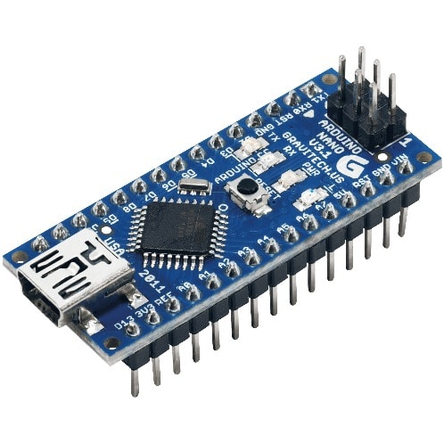

**Figure 3.5:** The circuit diagram of micro controller unit

**3.2 Principle of Operation**

On power up, the power supply unit provides 5V DC for the microcontroller, LED, SIM800L,Level Sensor and the GPS module. The microcontroller then initializes its internal registers and also the Location Detection.It then read the level signal from the Ultrasonic pin connected to the tank cover, converts the signal to the equivalent level,saves the value on the local storage and transmits the value to the registered number through the GSM/GPRS Module. When the user phone receives the data packet, it updates it on a map GUI interface. The microcontroller always listens for incoming packet, updates the GPS unit based on the received control packet. The entire process is repeated again.

**3.2.1 FLOW CHART**

INITIALIZATION

START

READ LEVEL SIGNAL from Ultrasonic Sensor

CONVERT IT INTO LEVEL VALUE

WAIT FOR CONTROL PACKET FROM GSM

GET LOCATION FROM GPS

END

SEND LOCATION TO USER

END

**3.2.2 Circuit Diagra**

